APPLICATION FORM 2026

Church of Ireland young adults and youth leaders/workers who can demonstrate a significant current involvement in the Church of Ireland.
3rd level qualifications - undergraduate and postgraduate courses, opportunities and placements that can be shown to:
Significantly develop the faith of the applicant.
Grow the skills of the applicant especially, but not confined to, youth ministry skills.
Be of significant use to the ministry of the Church of Ireland in the immediate 3 years following the completion of the opportunity.






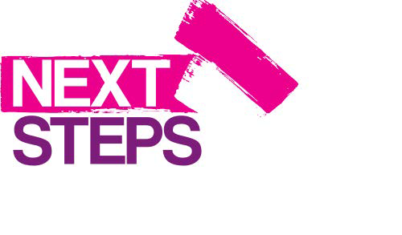


Successful applications must demonstrate to have met all three of these areas.
Applicants must be current members of the Church of Ireland - young adults/and/or youth leaders actively involved in youth ministry.
Bursary amounts would be granted to successful individuals following an application procedure and decided by the CIYD Executive Committee.
Applications would be restricted to one per person, per year.
Application deadlines would be 30th April and 31st October each year, from 2026 -2028 inclusive. Applications can be made while a course is on-going, but not after completion.
Applications cannot cover more than 50% of the total individual costs of any course.
Please note this fund is restricted and it may not be possible to award every applicant. Funds will be allocated on the strength of the application and availability of funds.

1

Name of Applicant:
Contact Address:
Postcode:
Contact Number:
Contact email: (Please note this email will be how we will communicate with you)
Parish:
Current age and Date of Birth:
If in full time education,
please state your current stage:
If employed, please state the nature/type of your employment: | C
Tell us about your involvement in your local Church of Ireland parish:

Qualification / Course details your application is in relation to:

How will this Qualification / Course etc grow your skills?
How will this Qualification / Course etc significantly develop your faith?

Tell us how you think you will be of significant use to the ministry of the Church of Ireland following the completion of the opportunity:

Please list contact details of your Rector/Minister In Charge for a reference:
Minister’s Name:
Parish & Diocese:
Phone Number:
Email address:

I confirm that to the best of my knowledge and belief, all replies given on this application form are true and accurate.
I understand that by accepting a grant from CIYD I agree to only use it for the purposes stated on this form.
Applicant’s Name (Printed):
Applicant’s Signature:
Date:

CIYD would like to keep in touch with you via email for youth ministry related opportunities, events and training opportunities that may be beneficial to you in the future. Please tick the box below if you would like your email address added to our database. For our privacy policy please visit www.ciyd.org

I consent to CIYD contacting me via email for the stated purposes above.

*PLEASE ENSURE THAT YOU MEET ALL OF THE ELIGIBILITY CRITERIA PRIOR TO SUBMITTING AN APPLICATION AND BY THE RELEVANT CLOSING DATE*

CLOSING DATES ANNUALLY ARE 30TH APRIL & 31ST OCTOBER.

Please email completed form to: admin@ciyd.org

For any further information or questions please contact: simon@ciyd.org
If your application is successful, CIYD will be in contact with you confirming bank transfer procedures to your organisation.

Please complete bank details on the next page.

BANK DETAILS
QUALIFICATION / COURSE

Name of Recipient:
Bank Name & Address:
Name of Account:
Account Number:
Sort Code:

